# 

# 

# 

# 

**PDD in the North American Market**

# 

Moyi, Joya, Irene, Harry

Research Report | 05/09/2024

# 

# Table of Contents

**Table of Contents 1**

**1. Introduction 2**

1.1 Introduction of the Acquiring Companies 2

1.1.1 Research Purpose 2

1.2 The Cause, Process and Result of the Brand Going Overseas 2

1.2.1 The Causes 2

1.2.2 Reasons for choosing the North American market as a starting point 3

1.2.3 Temu On-Line Timeline 3

1.2.4 Current situation of Temu 4

**2. Business Models 5**

2.1 Timeline Overview 5

2.2 Customer Management 6

2.2.1 Value Propositions 6

2.2.2 Client Segmentation 6

2.2.2 Customer Relationship Management (CRM) 8

2.3 Reasons for the Acquisition 8

2.3.1 Strengthening the Oncology Portfolio 8

2.3.2 Consolidating Presence in Canada 9

2.4 Statements from Company Executives 9

**3. North American Marketplace E-Commerce Industry Analysis & Market Performance 10**

3.1 Changes in the corporate structure 10

3.1.1 Independent operation 10

3.1.2 Management integration and retention 11

3.1.3 Financial integration 11

3.1.4 Integration of R&D resources 11

3.2 Changes in the corporate structure 12

3.2.1 Shareholders' shares and acquisition criteria 12

3.2.2 Adjustment of Dividend Policy 12

3.2.3 Impact of Strategic Integration on Shareholders 13

3.3 Financial Data 13

3.4 Market Challenges 14

**4. Summary - Key Factors for Temu's Success 14**

**References 15**

# 1. Introduction

## 1.1 Introduction of the Acquiring Companies

Temu's parent company is PDD Holdings, a Cayman Islands-registered company based in China, which also owns the popular Chinese e-commerce platform Pinduoduo. Its main warehouse is located in Boston, Massachusetts, USA and is a wholly owned subsidiary of Pinduoduo Holdings. The platform offers deeply discounted bargains on everything from clothing to electronics and furniture, most of which are shipped directly from China to consumers around the world. Temu will first launch in the US in 2022, followed by the UK and the rest of the world. The company currently has 10,000 employees, $61 billion in annual orders and $20 billion in cash.

### **1.1.1 Research Purpose**

Through an in-depth study of Temu's successful model in the North American market and comparative analysis, we hope to identify Temu's competitive strengths and weaknesses, try to find new market gaps and use this to assess the market potential in order to formulate a differentiated competitive strategy and provide a reference for our own business development.

## 1.2 The Cause, Process and Result of the Brand Going Overseas

### **1.2.1 The Causes**

There are several profound factors behind Pinduoduo's choice of brands to go overseas in 2022, and its initial choice of the North American market as a starting point.

The first is the increasingly fierce competition in the domestic market. As the domestic Internet entered a high-speed development stage after 2010, giants in the field of e-commerce platforms have emerged, with Alibaba, Jingdong and others occupying the main market share, Pinduoduo wants to get more growth space in the domestic market and faces huge competitive pressure. Second, the overseas market e-commerce track has great potential. Although overseas e-commerce started earlier than the domestic market, it is not as developed as the domestic market for various reasons. Therefore, there are more opportunities for the declining market in the mature North American market. These consumers have strong consumer demand but a lack of sufficiently low-priced goods, which is very suitable for Pinduoduo's user positioning. Finally, Pinduoduo is very good at combining its own advantages with its globalization strategy. The mature and large domestic low-price supply chain system and relatively low labor costs can provide sufficient sources of goods for overseas markets. Pinduoduo has not only adopted the excellent business model of Taobao and other platforms but also pushed the boundaries to create a special model of social e-commerce. The great success of this model at home makes Pinduoduo confident in its overseas development. Once the supply channels and customer sources in overseas markets are stabilized, Pinduoduo will become a global e-commerce giant.

### **1.2.2 Reasons for choosing the North American market as a starting point**

What are the deeper considerations for choosing North America as the first stop for overseas market expansion?

* **Market maturity:** North America is one of the most mature e-commerce markets in the world, and the market rules are relatively perfect, which is conducive to Pinduoduo's rapid market entry.
* **Similar consumption habits:** The consumption habits of North American consumers are similar to those of Chinese consumers, which is conducive to Pinduoduo's rapid market adaptation.
* **Perfect logistics infrastructure:** North America's logistics infrastructure is perfect, which can provide Pinduoduo with efficient logistics and distribution services.
* **Competition is relatively fragmented:** Compared with some other overseas markets, the competition in the North American market is relatively fragmented, which gives Pinduoduo more opportunities to occupy the market share.

**In conclusion**, Pinduoduo's decision to go overseas in 2022 and take the North American market as a starting point is based on a comprehensive assessment of the domestic and international market situation, as well as the full play of its own advantages. This strategic layout is not only to meet the challenge of increasingly fierce competition in the domestic market but also to seize the opportunity of global e-commerce development and achieve the long-term sustainable development of the company.

### **1.2.3 Temu On-Line Timeline**

Temu quietly entered the North American market in **early 2022**, attracting massive consumers with competitive prices and a rich product line.2022 Temu entered a period of rapid expansion in **mid-2022**, with large-scale marketing and promotion through social media, especially TikTok, triggering spontaneous sharing and spreading by users, and quickly creating a wave of "Temu fever" in overseas markets. During the same period, the low-price strategy paid off, successfully attracting a large number of price-sensitive consumers, especially the younger generation. In **late 2022**, Temu's growth began to face challenges and adjustments. Due to the surge in order volume, Temu's logistics system was under pressure, resulting in delays in the delivery of some orders. Other overseas e-commerce giants, such as Amazon, also felt the threat of launching countermeasures, and competition in the market began to intensify. But Temu's development is quite rapid. By the end of 2022, the Temu app had become the most downloaded app in the country. The shopping app quickly overtook Amazon and Walmart in terms of downloads in the US less than a year after its launch.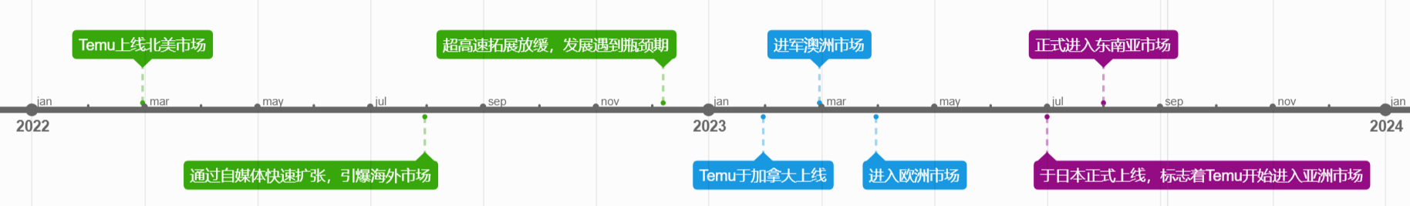

Figure 1.2.3.1 Timeline of Temu's launch

**As 2023 approaches**, Temu is no longer satisfied with the domestic market in the United States and has begun to further expand its channels abroad. **In the first half of the year**, Temu made strong inroads into the Canadian, Australian and European markets. **In the second half of the year**, Temu decided to return to Asia to explore the Japanese, Korean and Southeast Asian markets. According to survey data released by Wiseapp, a South Korean mobile application analytics service provider, Alibaba's Global Express and Pinduoduo's cross-border e-commerce platform 'Temu' (APP) have been expanding rapidly in the South Korean market, ranking in the top two in terms of new users in South Korea in the first 11 months of the market, and local e-commerce companies have been affected. Below is a bar chart of Temu's global monthly downloads. According to Bloomberg, in May 2023, Temu surpassed Shein in terms of users in the US, with more than 70 million people using the app.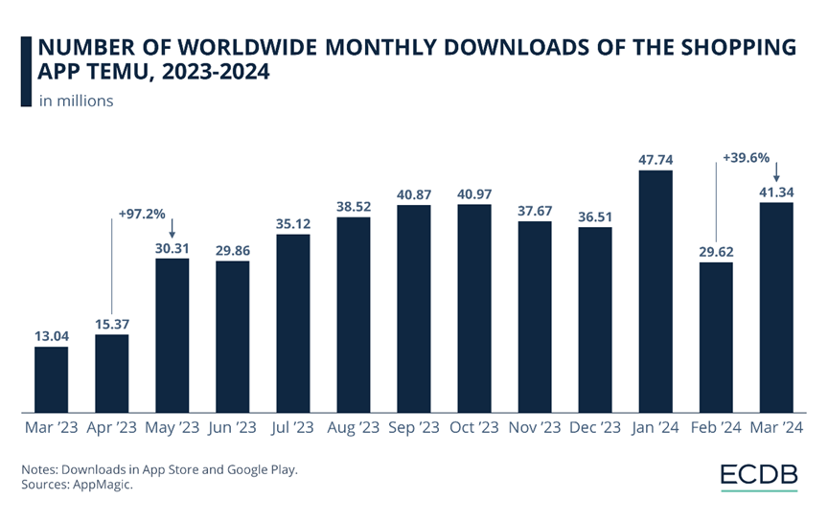

Figure 1.2.4.1 Number of Worldwide Monthly Downloads of The Shopping App Temu, 2023-2024 (In Millions)

Data Source: Appmagic

### **1.2.4 Current situation of Temu**

As a privately owned subsidiary of Poundland, although Temu's specific operating data is not publicly available, Temu's rapid global expansion and growing market share have resulted in strong revenue growth. Temu's low-price strategy and extensive product range have enabled it to achieve leading sales in many overseas markets. In the North American market, in particular, Temu has become one of the preferred shopping platforms for many consumers. Temu's overseas marketing has also been successful. The successful viral spread of TikTok has laid the foundation for its rapid expansion in overseas markets.

| Date | Gross merchandise volume (millions of US dollars) |
| --- | --- |
| 2022 | 290 |
| The first half of 2023 | 2896 |
| The second half of 2023 | 12260 |

Table 1.2.4.2 Temu's Total Merchandise Transactions, 2022-2023 (In Millions)

Data Source: YipitData

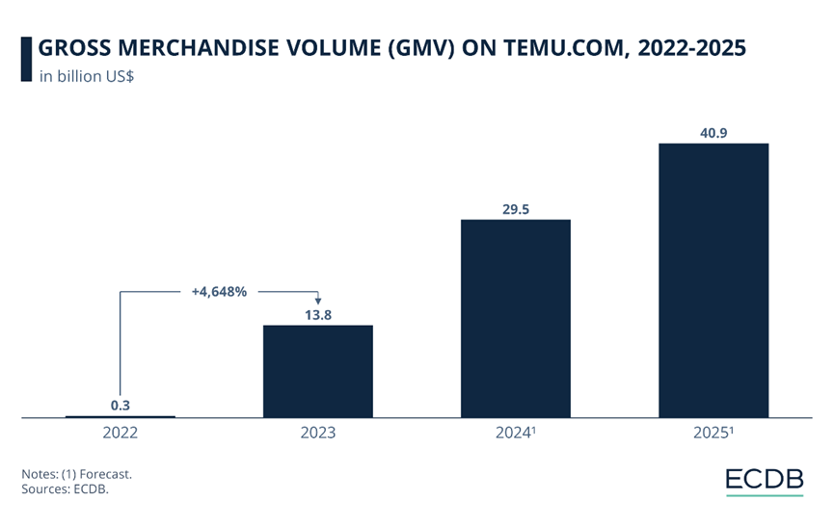

Figure 1.2.4.3 Gross Merchandise Volume (GMV) on Temu.com, 2022-2025

Data Source: ECDB

# 2. Business Models

## 2.1 Analysis of financial performance

### **2.1.1 Revenue and Profit Analysis**

#### **1) Main Revenue Sources**

* **Transaction Service Revenue**：TEMU's transaction service revenue mainly comes from commissions generated from platform transactions as well as gross profit of the business, etc. In Q4 2023, PDD's transaction service revenue amounted to RMB 40.21 billion, representing a 357% jump compared to RMB 8.8 billion in 2022, with Temu being an important source of the PDD Group's commission revenue boost.
* **Payment Channel Revenue**：payment channel revenue consists of main site commissions, DuoDuo Buying & TEMU revenue. In Q2 2024, Pinduoduo's payment channel revenue was RMB 47.1 billion, mainly driven by the rapid growth of TEMU. The Q2 GMV of TEMU exceeded USD 13 billion, which accounted for 50% of revenue.
* **Advertising and Marketing Revenue**：TEMU's advertising and marketing revenue is mainly derived from the advertising services it provides on its platform in Q3 2023, Pinduoduo's advertising and marketing revenue was RMB 39.7 billion, a 40% increase year-on-year, a portion of which is derived from TEMU's advertising revenue.
* **Product Sales Revenue**：Temu obtains products at a lower cost by directly cooperating with factory-type sellers and then sells them to consumers at a higher price to earn the difference. Although the company's current strategy has halted this business, there was still some revenue from product sales in 2023.

#### **2) Main Profit Analysis**

* **Gross Margin**：In 2023, Temu's pre-coupon gross margin was approximately 50%, with a platform subsidy rate of about 20%, resulting in a post-coupon gross margin of about 30%. As the cost of goods supplied by merchants is optimized and subsidies are reduced in the future, the gross margin is expected to increase. In Q3 of 2023, Temu's actual paid gross margin was 28.5%, and the annual actual paid gross margin was 29.2%, showing a continuous improvement in gross margin.
* **Net Margin**：The gross margin of Temu sellers is basically between 20-40%, and the net margin is basically between 5-15%. The net margin for some categories may be higher, but as competition within the platform becomes more intense, the net margin may be limited. The net profit margin of Temu merchants on the platform is generally higher than that of domestic Pinduoduo (about 5% on average), but merchants also worry that continuous price pressure from the platform and intensified competition may lead to thinner profits.
* **Loss Situation**：Despite Temu's high gross margin, the platform is still in a loss-making state. In Q3 of 2023, Temu's operating loss was $970 million, mainly including fulfillment and payment costs.

### **2.1.2 Cost structure analysis**

#### **1) Main cost structure**

Temu's operations involve a variety of costs, which not only have a direct impact on its financial performance, but also determine the company's overall profitability. Here are Temu's key cost structures and their key impacts on the company's operations：

* **Purchase cost**：As an e-commerce platform, the purchase cost of goods is one of the most core expenditure items of Temu, which involves various costs of purchasing goods from suppliers. This part of the cost directly affects the performance of the gross profit margin and occupies an important position in the operating cost. Although Temu has adopted a "bidding list" model to control the cost of restocking, the expense still poses a challenge to the company's short-term profitability.
* **Platform Subsidies**：In order to increase user activity and promote user growth, Temu attracts and retains users through the form of platform subsidies (including discounts, cash vouchers, etc.). While such promotions increase the operating burden in the short term, resulting in limited platform profitability, in the long term, continued user growth and increased brand recognition may lay the foundation for future profitability.
* **Acquisition costs**：Temu acquired users through advertising, marketing and other marketing strategies, which played a critical role in increasing market share and brand recognition. The effective control of customer acquisition cost is one of the key factors for a company to maintain market competitiveness.
* **Human Costs**：Human costs cover all levels of spending, from technology development and customer support to management. Temu's workforce is not only key to supporting its day-to-day operations, but also plays a vital role in improving the overall efficiency of the platform and the user experience.
* **Warehousing Costs**：To ensure the stability of the commodity supply chain, Temu's expenditure on warehousing facilities is critical. Warehousing costs, including inventory storage, warehouse maintenance and other costs, directly affect the efficiency optimization of the company's logistics chain.
* **Logistics Costs:** Logistics is another important part of e-commerce operations, involving the cost of transporting goods from the warehouse to the end user. Logistics related expenses such as express fees and distribution fees are important factors affecting customer satisfaction, and effective control of logistics costs can further reduce the overall operating costs.

#### **2) High upfront costs**

In the company's early market expansion phase (September 2022-September 2023), Temu faced high upfront costs and incurred a loss of RMB4.995 billion. From the perspective of **cost structure, purchase cost, platform subsidy and logistics cost** are the three major expenditure items of the company in the early stage, **accounting for 85%, 31.05% and 6.67% of GMV respectively**. Although the purchase cost has been significantly reduced through the "auction listing" model, Temu has invested a lot of money in platform subsidies, advertising, and logistics expenses such as free shipping and free returns in order to expand the market quickly. These expenditures, while adding to short-term financial pressure, are critical to increasing brand exposure, stimulating conversion rates, and driving user growth.

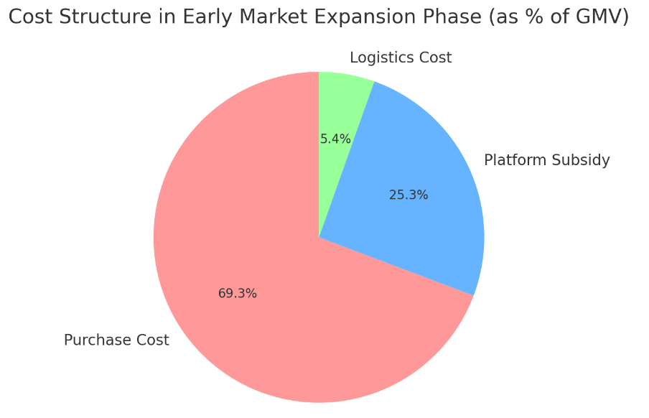

Figure 2.1.2.1 Cost structure in the early market expansion phase (September 2022 to September 2023)

Data Source: China Merchants Securities

#### **3) Improvement of cost control in recent years**

In the fourth quarter of 2023, Temu made significant progress in cost control. According to the research report of China Merchants Securities released in March 2024, the company's sales expenses, administrative expenses and research and development expenses in the quarter were 26.64 billion yuan, 1.90 billion yuan and 2.86 billion yuan, respectively, and the expense rate was reduced by 14.6 percentage points, 2.0 percentage points and 2.8 percentage points, respectively. Behind the cost reduction is the continuous release of scale economies and the company's continuous optimization in marketing and management efficiency.

In the quarter, Temu's Non-GAAP net profit attributable to the parent reached 25.48 billion yuan, an increase of 110% year-on-year, exceeding market expectations. This increase was mainly due to the steady improvement of the main station earnings and the significant narrowing of the loss in the North American market. It is expected that in the future, as the company further expands in the market, the scale effect will continue to strengthen, and the improvement of cost control will also provide strong support for the continued growth of profitability.

## 2.2 Customer Management

### **2.2.1 Value Propositions**

Chinese suppliers in Temu can sell goods directly to overseas customers and ship globally without the need for intermediary distributors in the destination country, allowing them to keep prices low to attract consumers. The business model also aims to expand the customer base by reducing logistics and margins for sellers. In addition, Temu offers free goods to several users who have been successful in attracting new users to Temu through affiliate codes, social media and gamified marketing. Users can shop on Temu using a web browser or a dedicated mobile app. Unlike Amazon's business model, which sells user consumption data to manufacturers at a premium, Temu collects data on consumption trends, searches and products with the most clicks and provides this data to individual manufacturers free of charge.

### **2.2.2 Client Segmentation**

**Broken down by demographics**, the data shows that the largest age group of shoppers using temu.com is 25-34 years old, representing 21% of the audience. The next largest age group (35-44) is 20%. While the older age groups make up a decreasing proportion of the audience, with 18% of users aged 45-54 and 16% of users aged 55-64, the youngest age group (18-24) is the second smallest (13%) of age groups using the site. Only the over-64s had a lower percentage (12%). **Clearly, the shopping site attracts interest from a wide age range of consumers.**

**In terms of behavioral segmentation**, the proportion of high-frequency shoppers is higher in terms of shopping frequency, and they tend to make impulse purchases. In terms of category preference, clothing, beauty and household products are the main shopping categories. In terms of channel preference, shopping is mainly done via mobile and social media is an important source of information.

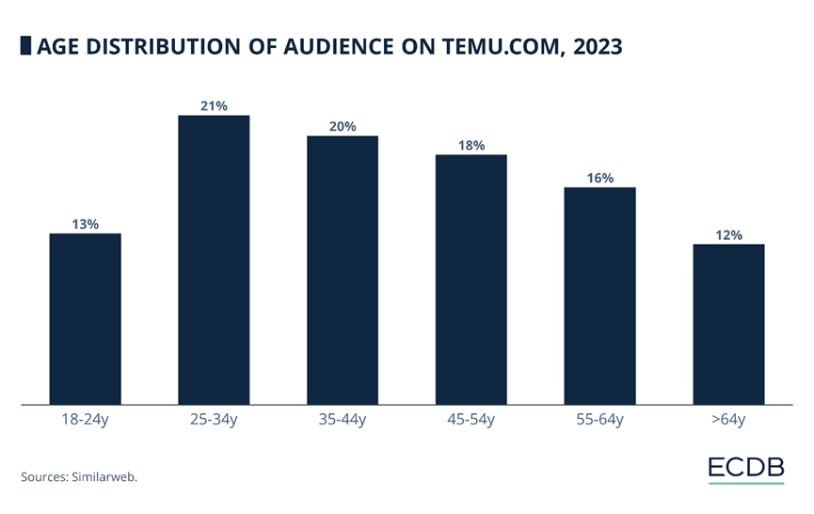Figure 2.2.2.1 Age Distribution of Audience on Temu.com, 2023

Data Source: Similarweb

Figure 2.2.2.2 Number of Monthly Visits on Temu.com, 2023-2024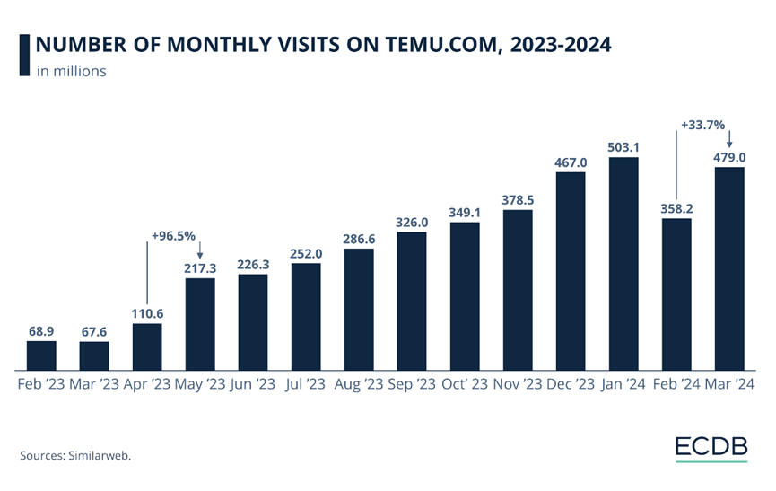

Data Source: Similarweb

### **2.2.3 Customer Relationship Management (CRM)**

Temu has also put a lot of effort into customer relationship management, starting with personalized recommendations. Temu can provide users with personalised product recommendations based on data such as the user's purchase history and browsing behavior to enhance the shopping experience. The social shopping model created by its parent company has been transplanted to Temu, and the site encourages users to share shopping tips and participate in community interactions to increase user stickiness. Finally, a lot of advertising and promotion is done through social media platform marketing, such as TikTok, to increase brand influence and attract new users. For Temu, the customer relationship has the following characteristics

* **Youthful:** Temu's customer base is dominated by the younger generation who seek personalisation, and value for money and are highly dependent on social media.
* **High-frequency shoppers:** Temu's users shop more frequently and are sensitive to new products and promotions.
* **Price sensitive:** Price is an important factor in users' purchasing decisions.
* **Socialization:** Social media plays an important role in Temu's customer relationships, with users using social media to get information and share shopping tips.

## 2.3 Key Activities & Key resources

### **2.3.1 Key Activities**

Temu currently operates in a semi-direct model with the following key activities：

* **Merchant Onboarding & Recruitment:** The merchant recruitment efforts in the North American market for TEMU are led by Gu Pingping, COO of Pinduoduo, with several top-level executives from Duoduo Maicai responsible for the recruitment in the U.S. market. In terms of merchant onboarding, TEMU has accumulated 90,000 suppliers, 55% of whom come from the main platform of Pinduoduo and Duoduo Maicai, mostly being white-label merchants.
* **Product Selection and Pricing:** TEMU focuses on low-priced best-selling products, quickly acquiring users through high cost-performance goods. The platform is responsible for product selection, operation, promotion and customer service, adopting a strategy of 0 commission, 0 service fee, and 0 return fee, supporting international logistics.
* **Merchant Delivery:** The logistics process of TEMU in the North American market includes the first leg, long-distance international transportation, and the last mile delivery. The platform reduces logistics costs by choosing the shipping day with the lowest freight cost and matching shipments to fully utilize the aircraft's load space. TEMU cooperates with multiple logistics companies, such as Italian Post, CTT, and Mail Alliance, to improve delivery efficiency in the North American market.
* **Marketing and Promotion:** TEMU has invested a large amount of marketing expenses in the North American market, promoting through advertising platforms and large-scale events. In Q3 of 2023, TEMU's marketing expenses were 14.1 billion yuan, a nearly 400% increase compared to the 3 billion yuan of the previous year. In 2023, Temu launched at least 26,000 advertisements, with overseas marketing costs of about 26.36 billion yuan, mainly in the U.S. market. According to Sensor Tower, Temu's main channels for advertising in the U.S. are Facebook, Instagram, and YouTube, with the first two accounting for 61% of advertising costs and 64% of exposure.
* **Order Generation and Fulfillment Delivery:** The platform is responsible for order generation and fulfillment delivery, ensuring that products can be delivered to consumers on time. By consolidating orders for fulfillment, it controls the logistics costs throughout the entire chain and allows low-value lightweight products to enter the cross-border circulation chain.
* **After-Sales Service:** The TEMU platform undertakes the after-sales service process, reducing the difficulty of after-sales processing for merchants. Under the full management model, the platform ensures the quality of products and the efficiency of after-sales service through control of the entire chain.

## 

Figure 2.3.1 Key Activities & Key resources of Temu

Data Source:Temu official website, Tianfeng Securities Research Institute

### **2.3.2 Key Resources**

#### **1) Team Resources**

The Temu team possesses exceptional combativeness. Led by Gu Pingping, COO of Pinduoduo, Temu has assembled a team with super combat experience from the original Duoduo Maicai staff. Dong Zao and Pu Tao, former provincial level executives of Duoduo Maicai, are in charge of North American merchant recruitment; the Temu buying team continues to employ most of the purchasing personnel from Duoduo Maicai. Moreover, Temu is actively recruiting members with experience in top cross-border e-commerce platforms. According to 36Kr, Temu's frontline team and management team total around 700 people, including a 50-person merchant recruitment team, a 30-person buying team, and a 50-person platform operation team. As Pinduoduo's top priority project, Temu has the privilege of selecting talents first within the company and is expected to be given a higher tolerance for initial losses.

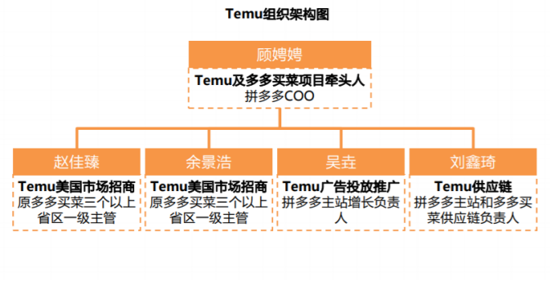

Figure 2.3.2 organization chart

Data Source:Temu official website, Tianfeng Securities Research Institute

#### **2) Parent Company Financial Resources**

PDD provides strong financial support for Temu. In September 2022, when Temu was just launched in the United States, Liu Jun, the CFO of Pinduoduo, stated at the earnings call that Temu is not driven by financial indicators. According to the financial report, in terms of revenue, Pinduoduo's operating income in 2022 was 130.558 billion yuan, a year-on-year increase of 39% compared to 2021; in terms of net profit, the net profit attributable to ordinary shareholders in 2022 was 31.538 billion yuan, a year-on-year increase of 306%; in terms of cash flow, as of December 31, 2022, Pinduoduo's cash, cash equivalents, and short-term investments amounted to 149.4 billion yuan. Since the launch of Temu in September 2022, PDD's financial report for the third quarter of 2022 showed that marketing expenses were 14.049 billion yuan, an increase of about 40% compared to 2021, and perhaps a large part of it was used for the marketing and promotion of Temu.

## 2.4 Market Strategy

Similar to TikTok's marketing strategy when entering the U.S. market, TEMU is currently in a "spend aggressively for market exposure" phase, where it is prioritizing market penetration at the expense of short-term profitability. From its U.S. launch in September 2022 until December 2023, TEMU's advertising spend exceeded $517 million. According to MediaRadar's advertising data, TEMU allocated $505 million to advertising in 2023, representing a 1,000% increase in marketing expenditures. Shortly after entering the North American market, TEMU aired five ads during and around the Super Bowl, often referred to as "America's biggest TV event," cementing its tagline "Shop Like a Millionaire" in the minds of U.S. consumers. Following the Super Bowl ads, TEMU climbed to the top spot in the Apple Store’s free app downloads ranking.

Additionally, TEMU introduced the innovative slogan "Team Up, Price Down," which aligns with Pinduoduo's group buying strategy. This phrase, being a new concept, piqued public curiosity, while the use of a vibrant orange color in its branding further stimulated consumer purchasing desire.

TEMU also replicated Pinduoduo’s core strategy of social viral marketing. By encouraging users to voluntarily share information about TEMU within their social networks, it achieved exponential growth in exposure with minimal traffic acquisition costs. TEMU released numerous short videos on platforms like TikTok, YouTube, and Twitter to showcase its product offerings, often including limited-time coupons to entice new customers. This aggressive marketing strategy, coupled with extremely low prices and discounts, has helped TEMU attract a substantial customer base and carve out its own distinct brand identity.

## 2.5 Localized Marketing Strategy and Supply Chain

* **Cross-border e-commerce from China**

Platforms like Temu and Shein extensively utilize the "de minimis" provision, allowing products valued under $800 to be shipped directly from China to U.S. consumers without incurring customs duties. However, this business model is undergoing a significant transformation as regulatory environments evolve. Temu's strategy in the U.S. market is gradually aligning more closely with Amazon's localized operational model.

* **The shift from full management to partial management**

During its early expansion phase, Temu adopted a zero-commission, zero-entry policy, where merchants only needed to ship products to domestic warehouses. This significantly lowered the barrier for businesses to enter the international market while enhancing the platform's ability to aggregate resources. However, as the platform grew rapidly, challenges related to logistics efficiency began to emerge, particularly as the product range expanded from small to larger items.

To address these issues, Temu introduced a partial management model, granting logistics and after-sales autonomy to merchants with local shipping capabilities. This shift not only allowed for the inclusion of larger product categories but also improved delivery efficiency. Additionally, local-to-local shipping eliminated the need for cross-border transport, reducing Temu’s fulfillment costs. Beyond its full and partial management models, Temu has iterated on its supply chain operations to further reduce costs and drive platform expansion.

* **Supply chain partners**

Currently, TEMU primarily focuses on exporting domestic products, with its supply chain organized into a three-stage logistics system: the first leg (from domestic sellers to warehouses), international trunk shipping, and overseas last-mile delivery. For the first leg of transportation, TEMU employs a centralized warehousing model: merchants deliver products in advance to Temu's warehouses located throughout Guangdong, which are then consolidated and airlifted to overseas destinations by the platform.

At this stage, TEMU's supply chain remains centered on the Chinese market, with its key logistics providers being domestic companies. The primary logistics partners for Temu are Jitu Express and Yuntu. While both Jitu and Yuntu offer last-mile delivery services, they have not established a network in the United States; instead, they procure services from local logistics providers such as UPS, FedEx, and USPS. Jitu primarily collaborates with USPS for last-mile delivery, while Yuntu mainly partners with UPS.

However, the timeliness issues associated with exporting domestic products present significant barriers for TEMU as it seeks to penetrate broader markets and customer bases, making the localization of its operations imperative.

# 3. North American E-commerce Industry Analysis & Market Performance

## 3.1 Major Competitors

### 3.1.1 Shein



*Figure 3.1.1 Shein logo*Source: ExchangeWire.com

Shein is an online fast fashion retailer headquartered in Singapore, founded by Chris Xu in 2008 in Nanjing, China. Shein operates in over 150 countries and regions globally, and its e-commerce platform is highly popular worldwide, especially among millennials and Gen Z. As of April 2024, Shein's market value has exceeded $60 billion, making it one of the leading fashion retail platforms globally. In 2024, Shein also experienced several major events:

* **Shein Tops Global Shopping App Charts for Seven Consecutive Months**According to the global shopping app rankings for February released by the authoritative institution PYMNTS, Shein has ranked first for seven consecutive months, with a comprehensive score of 89. AliExpress and Alibaba International Station ranked second and fourth, respectively, while Amazon ranked third with a score of 82. Shein’s global presence and influence further solidified its position, and its namesake apparel brand is now ranked alongside global fashion giants like Zara, Uniqlo, and H&M. In recent years, Shein’s platform model has continuously expanded, with global traffic and user engagement steadily increasing.
* **Shein Ranks Third Among U.S. Fashion Retailers**In May, according to data from the ECDB website, Shein ranked third among U.S. fashion retailers. The ECDB website noted that Shein offers trendy fashion products at extremely low prices and continually introduces new items. Thanks to this strategy, Shein, which only launched in the U.S. around 2017, has surpassed traditional American retailers like Macy's (ranked fourth) and Nike (ranked fifth), whose 2023 fashion net sales were $6.4 billion and $4.5 billion, respectively.
* **Shein May Go Public in the U.K.**As of early June 2024, Shein has secretly submitted documents to the U.K. market regulator for a listing in London, potentially becoming one of the largest IPOs of 2024 globally. If successful, it could be the second-largest IPO in U.K. history. However, earlier reports suggested that Shein had secretly filed for an IPO with the U.S. Securities and Exchange Commission, but the process did not go smoothly.

### 3.1.2 AliExpress



*Figure 3.1.2 AliExpress logo*Source: Wikipedia

AliExpress, launched in 2010 by Alibaba Group, is an online retail service headquartered in China. Initially starting with a B2B (business-to-business) model, it later expanded to B2C (business-to-consumer), C2C (consumer-to-consumer), cloud computing, and payment services, offering various cross-border e-commerce solutions. Sellers on AliExpress can be both companies and individuals, and unlike Amazon, AliExpress only provides an e-commerce platform service without directly selling products. In 2024, AliExpress adopted a semi-managed operation model, aiming to share operational responsibilities with sellers, leveraging the advantages of both platform resources and capabilities. The impacts of this reform include:

* **Improved Logistics Efficiency and Fulfillment Capability**:  
  AliExpress upgraded the logistics process of the seller self-operation model (POP model) to be handled by the platform. This move significantly improved the seller’s fulfillment efficiency, helping them quickly overcome logistics shortcomings, thereby boosting order growth.
* **Increased Seller Participation and Profit Margin**:  
  The semi-managed model, previously available only by invitation, has now been opened to all sellers, attracting a large number of participants. Compared to full management, sellers in the semi-managed model have more autonomy, including pricing and store operations, enabling them to achieve greater profit margins.
* **Platform Support and Subsidies to Lower Operating Costs**:  
  To encourage sellers to join the semi-managed model, AliExpress has provided several subsidies and incentives, including logistics subsidies, commission waivers, and waived warehouse fees. These supports have effectively reduced the sellers' operating costs, increasing their enthusiasm for participating in the semi-managed model.
* **Enhanced Consumer Experience and Increased Order Conversion Rate**:  
  Through semi-managed logistics, the platform ensures faster and more reliable delivery of goods. Semi-managed products can also enter the Choice channel, enjoying free shipping, fast delivery, and free returns, thereby improving the consumer shopping experience and driving rapid order growth.

In conclusion, Temu targets a broad consumer base seeking value for money, Shein appeals to younger, fashion-driven users, especially Gen Z, while AliExpress caters to global buyers with a wide range of product categories. In terms of competition, Temu and Shein are fiercely competing on price and fashion, while AliExpress differentiates itself through product quality and service.

## 3.2 Traffic Comparison Across Major Platforms

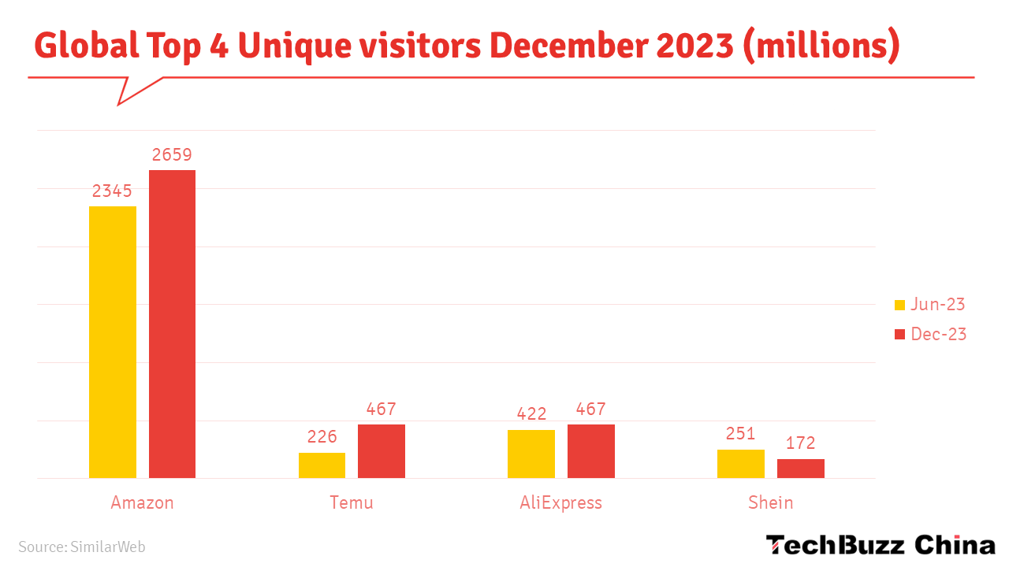

*Figure 3.2.1 December 2023 Traffic for Four Major E-commerce Platforms (Million)*Source: Similarweb

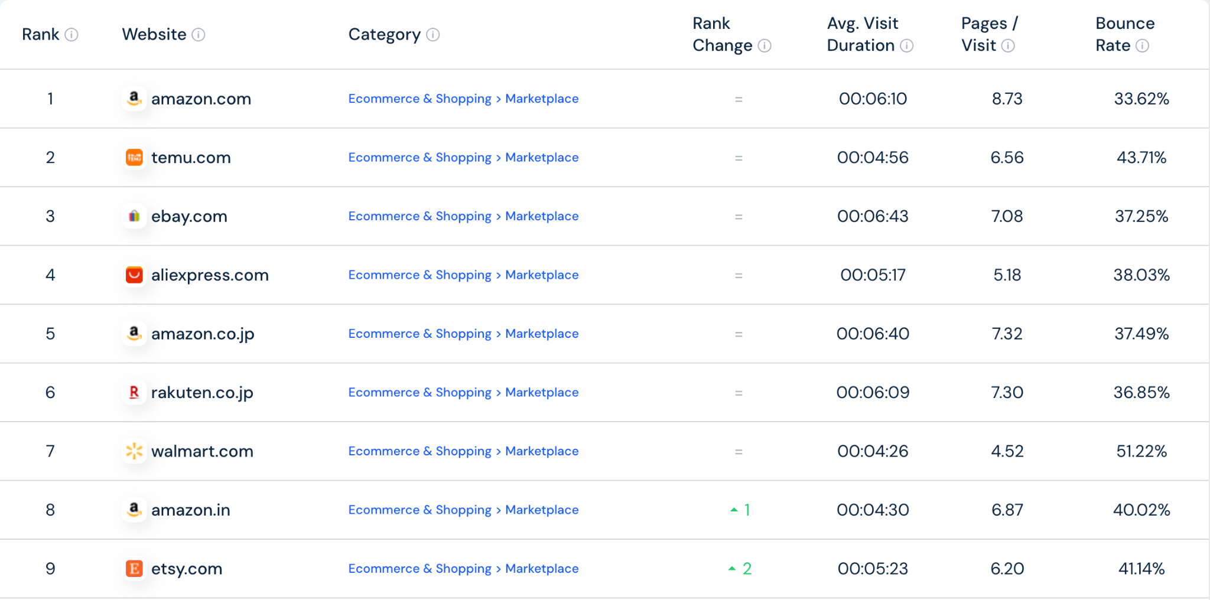

*Figure 3.2.2 August 2024 Top Nine E-commerce Platforms by Traffic*Source: Similarweb

This chart shows the traffic ranking of major e-commerce platforms in August 2024. Amazon remains firmly at the top, demonstrating its strong influence and vast user base globally. Following closely is Temu, a platform that has rapidly risen in recent years, ranking second, showcasing its ability to attract users with low prices and a wide variety of products. AliExpress, a platform known for cross-border e-commerce, ranks fourth, maintaining its key position in the global market. Notably, Shein did not make it to the top rankings, indicating that despite its prominence in the fashion e-commerce sector, it has not managed to compete with more comprehensive platforms in overall e-commerce traffic.

From a product category perspective, most of the top 20 platforms are comprehensive e-commerce platforms, covering multiple product categories to meet diverse consumer needs. Only two vertical category e-commerce platforms made it to the top 20: Etsy, known for handmade products, and Zalando, focused on fashion. This suggests that while vertical e-commerce platforms hold strong competitiveness in specific areas, their user coverage is relatively limited compared to comprehensive platforms. Shein, as a representative of fashion e-commerce, likely did not rank due to its narrower product focus. While Shein has carved out a unique brand positioning in the fashion sector, this strategy has somewhat limited its consumer base's breadth.

Furthermore, it is noteworthy that among the top 20 platforms, eight sell their own products, while the remaining 12 rely primarily on third-party sellers for product supply. This trend indicates that selling self-branded products remains an important way for many platforms to differentiate and increase profits. At the same time, these data also show the critical role of third-party sellers for e-commerce platforms, as they help attract more consumers through a wide range of product selections and flexible market responses. Geographically, five of the top 20 platforms have extensive global footprints: Amazon, eBay, Rakuten, AliExpress, and Etsy. Through cross-border operations, they have further expanded their market share, demonstrating the strong vitality and market penetration of globalized e-commerce platforms. These global platforms not only hold significant positions in their home markets but also successfully increase their user base and brand influence by expanding into other regions.

## 3.3 Market Evaluation

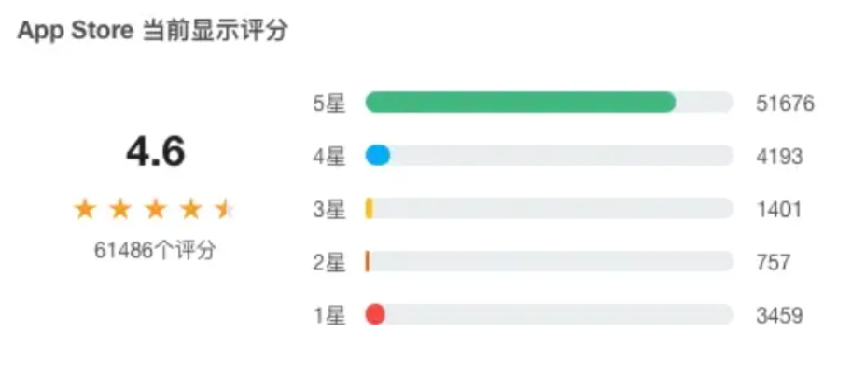

*Figure 3.3.1 Temu Rating on Apple Store*Source: Sohu.com

Despite Temu’s steady growth in platform traffic, user evaluations of Temu show a clear polarization. On the Apple Store, Temu has garnered a total of 61,486 user ratings, with an average score of 4.6, far exceeding the app store’s average score of 4.53, indicating its popularity among users. Notably, over 50,000 users gave it a five-star rating, highlighting Temu’s widespread influence globally and reflecting high user satisfaction with its service and product quality.

However, there is also a portion of users who expressed dissatisfaction with Temu, as approximately 3,000 users gave it the lowest one-star rating. Issues raised in these negative reviews likely include product quality, logistics speed, or user experience. Despite the presence of negative reviews, the proportion of one-star ratings is relatively small compared to the overall number of ratings and has not significantly impacted Temu's overall rating.

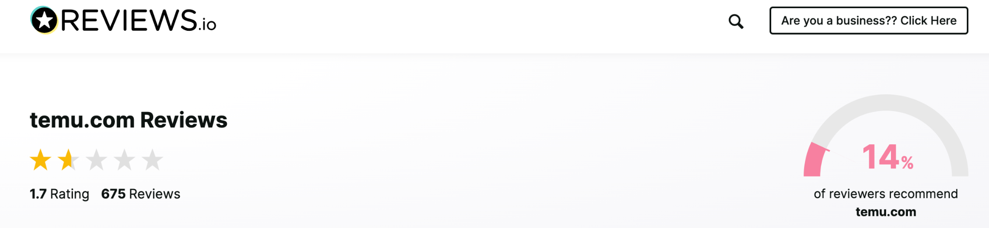*Figure 3.3.2 December 2023 Traffic for Four Major E-commerce Platforms (Million)*

Data Source: Reviews.io  
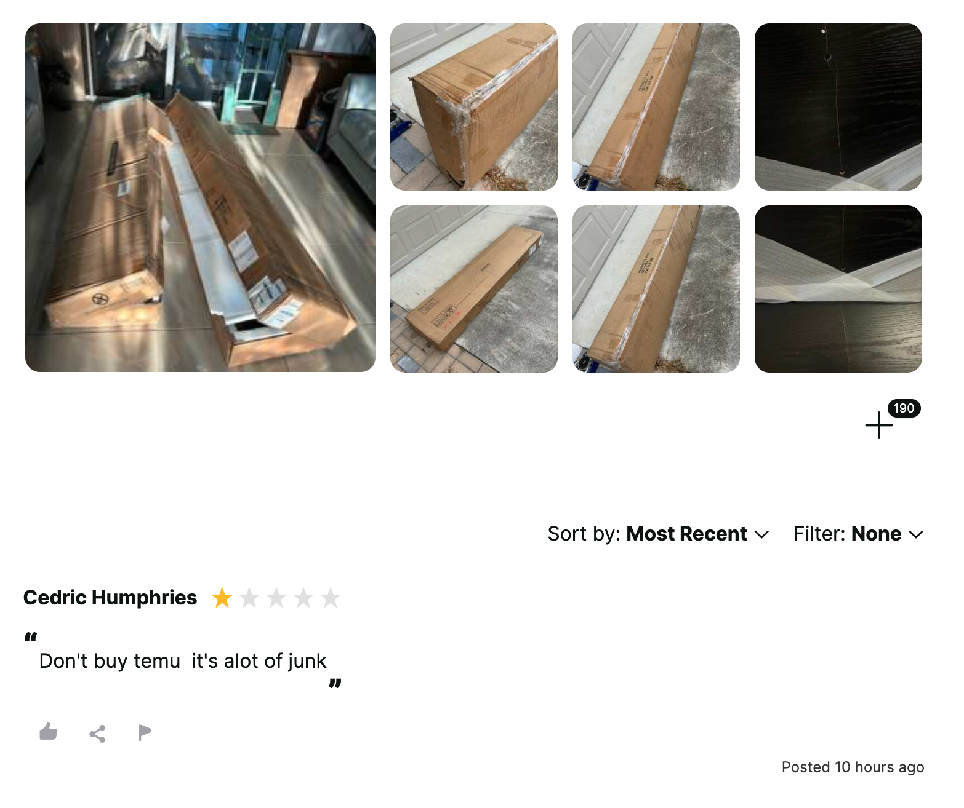

*Figure 3.3.3 User Review Screenshot*Data Source: Reviews.io

However, on the non-official website Reviews.io, Temu’s rating is only 1.7, indicating a lower level of user satisfaction with its overall service and quality. Data shows that only 14% of users would recommend Temu to others after shopping on the platform. Negative reviews mainly focus on three aspects: first, product quality issues, with some users reporting discrepancies between the received items and their descriptions, especially with certain electronics and counterfeit products, leading to a poor shopping experience. Secondly, packaging issues were raised, with some users noting that products were not adequately packaged, even arriving damaged during shipping, affecting satisfaction with the items. Lastly, logistics issues were mentioned, with complaints about slow shipping, with some orders taking weeks or even months

## 3.4 Market Challenges

Temu, a fast-growing cross-border e-commerce platform, has achieved great success but still faces many challenges. Below are some of the key market challenges that Temu may face:

1. **Global economic downturn and inflation**, as evidenced by consumer retrenchment and rising logistics costs. As global economic uncertainty increases, consumers are likely to focus more on value for money, which could put some pressure on Temu's margins. Meanwhile, rising logistics costs due to inflation may put pressure on Temu's margins.
2. **Intense market competition in the form of homogenisation and giant encirclement.** With the success of Temu's model, more and more competitors are entering the market, intensifying homogenisation competition. And giants such as Amazon and eBay may increase their investment in the low-price market, posing a direct threat to Temu.
3. **Supply chain risk.** Geopolitical risks, epidemics and other factors can lead to instability or even disruption of the global supply chain, affecting the supply of goods. In addition, the low-price sales strategy has been maintained for a long time, so the problem of product quality often comes to the fore.
4. **Brand image building.** Including two aspects, one is to get rid of the label of cheap products, and the other is to establish brand differentiation, Temu needs to continue to improve its brand image, find its own unique positioning, differentiate itself from competitors, get rid of the label of "cheap", and attract more high-end consumer groups.
5. **Logistics and warehousing.** As the scale of operations increases, so do the costs of logistics. How to efficiently manage global warehousing and ensure timely delivery of goods is a major challenge.
6. **Improving the user experience:** How can Temu more accurately recommend products to users and improve their shopping experience? How to improve the level of customer service to solve the problems users encounter during the shopping process? Consumers in different countries and regions have different consumption habits and cultural preferences, how can Pinduoduo adapt to these differences? These are all questions that need to be considered in the future.

# 4. Summary - Key Factors for Temu's Success

### **4.1 Integration and optimization of advanced supply chain**

Temu's success is largely dependent on its integration into China's advanced low-price supply chain. This supply chain system is based on the mature supply chain foundation of Pinduoduo, and through strict screening and filtration mechanism, the formation of a more competitive and digital ability of the "advanced supply" system. By integrating China's industrial clusters and low-cost labor advantages, Temu is able to provide cost-effective goods to meet the global consumer demand for "cost-effective". It is worth noting that more than half of Temu's suppliers come from core factories within Pinduoduo's existing system. These plants are equipped to deal with highly competitive markets and are able to withstand extremely low price pressures to provide continuous product support for the platform.

#### **4.2 Profit model innovation and space expansion**

Compared with traditional e-commerce platforms, which rely on commissions and advertising fees as their main revenue sources, Temu makes profits through the price difference between direct purchasing and retail, successfully restructuring the profit distribution along the value chain. This innovative model significantly broadens the profit space of the platform and enhances its competitive advantage in the market. Instead of simply acting as an intermediary between merchants and consumers, Temu has vastly expanded its revenue stream by taking control of the entire purchasing and retail process, pocketing most of the profits in the chain.

#### **4.3 Flexible operation of full and semi-managed**

Temu adopted a fully managed model in the early days, with the platform as the dominant player and strict control of the ecosystem to ensure a high degree of dependence on the platform. By adhering to the low-price/traffic linkage mechanism, the platform strengthens the control of merchants' traffic allocation and uses unequal rules to force merchants to sell goods under the low-price strategy. In order to obtain more traffic, businesses must accept the circular mechanism of "profit for traffic", forming a dynamic operation mode of the platform to attract consumers and merchants to re-purchase traffic.

In addition, Temu has gradually introduced a semi-managed model, allowing some merchants to enjoy more autonomy in areas such as logistics and customer service. The introduction of this model not only improves the flexibility and adaptability of the platform, but also further reduces the operating costs of the platform, and provides greater support for the rapid listing and sales of specific categories of goods. Temu is able to maintain the stability of its supply chain and the operational efficiency of its platform through the flexible operation of both full and semi-managed models.

# 

# 

# 

# 

# 

# References

[1] AstraZeneca. (2024, August 5). In *Wikipedia*. <https://en.wikipedia.org/wiki/AstraZeneca>

[2] Cancer treatment. (2024, August 5). In *Wikipedia*. <https://en.wikipedia.org/wiki/Cancer_treatment>

[3] AstraZeneca, 2024, H1 and Q2 2024 Financial Results <https://www.astrazeneca.com/media-centre/press-releases/2024/h1-and-q2-2024-results.html>

[4] AstraZeneca, 2024, Completion of Fusion Acquisition <https://www.astrazeneca.com/media-centre/press-releases/2024/acquisition-of-fusion-completed.html>

[5] Acquisition of Fusion completed. (2024). <https://www.astrazeneca.com/media-centre/press-releases/2024/acquisition-of-fusion-completed.html>

[6] AstraZeneca to acquire Fusion to accelerate the development of next-generation radioconjugates to treat cancer. (2024). <https://www.astrazeneca.com/media-centre/press-releases/2024/astrazeneca-to-acquire-fusion.html>

[7] AstraZeneca Announces Major Investments in Ontario’s Life Sciences Sector. (2023). <https://www.newswire.ca/news-releases/astrazeneca-announces-major-investment-in-ontario-s-life-sciences-sector-820870723.html>

[8] DeVol, R. C., Bedroussian, A., & Yeo, B. (2011). The global biomedical industry: preserving US leadership. *Milken Institute*, *5*.

[9] Lee, J. S. (2018). *Being A Biomedical Entrepreneur-Growth Of The Biomedical Industry*. World Scientific.

[10] Pharmaceuticals, F. (2024). Fusion Pharmaceuticals Announces Presentation of Interim Data from the Phase 2 TATCIST Clinical Trial Evaluating FPI-2265 at the AACR Annual Meeting 2024. <https://www.prnewswire.com/news-releases/fusion-pharmaceuticals-announces-presentation-of-interim-data-from-the-phase-2-tatcist-clinical-trial-evaluating-fpi-2265-at-the-aacr-annual-meeting-2024-302112266.html>